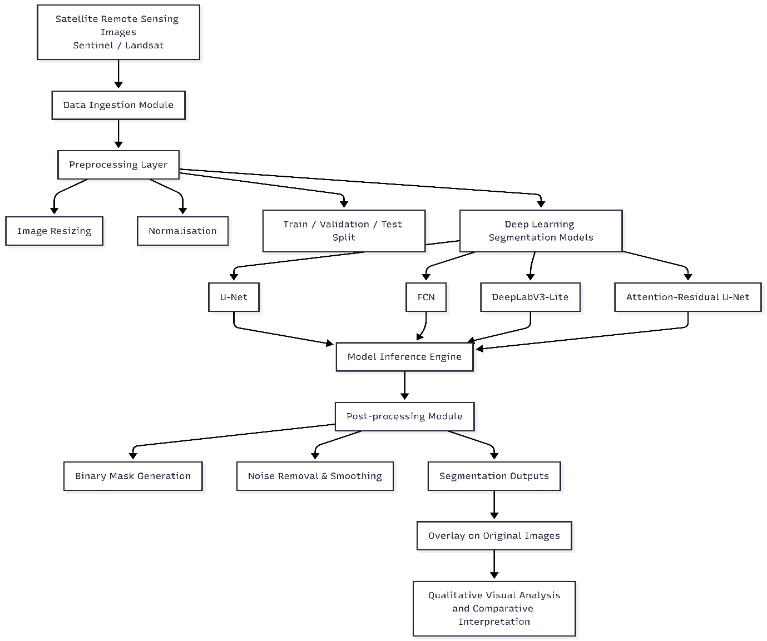
Architecture of the Project

Algorithms will be used for Comparative analysis are :
U-Net, Fully Convolutional Networks (FCN), DeepLabs-based models, attention-enhanced networks

Started designing the block diagrams for the coming week .

